SEMINAR INVITATION PRELIMINARY

Cross-border Serious environmental crimes as a theme at Gimborn

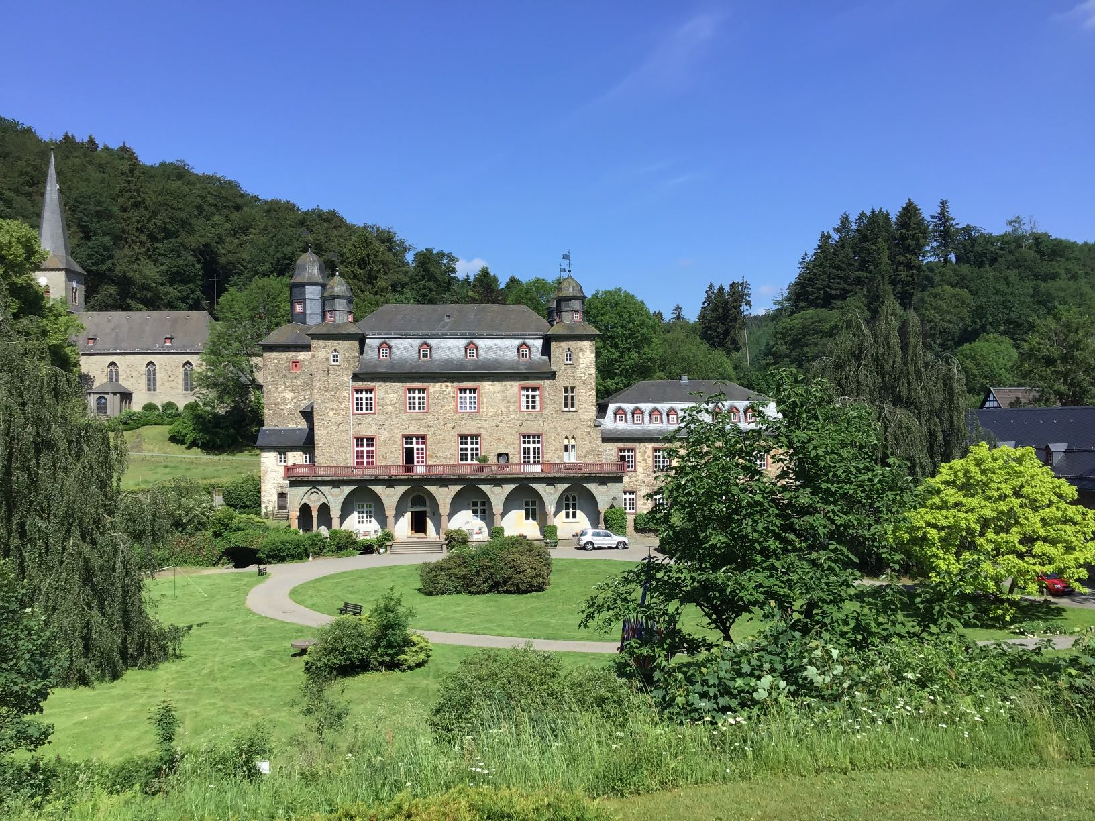

The Environmental Crime Seminar will be held from 2nd to 6th of September 2019 at the International Police Association IPA Gimborn Training Center in Germany. The seminar is hosted and convened for the second time by the IPA Section Finland. The event will represent top of their field Finnish and international lecturers across Europe. The content of the seminar will consist of various aspects of tactical and technical investigation in environmental crimes as well as current research in the field.

During the days will be introduced crime and justice cases in different countries, operational practices in this field, evolving criminal investigation methods, development and research projects in this field as well as cooperation between authorities involved in the fight against environmental crimes. The main target groups in the seminar are members working in environmental crime investigation and prevention duties but the seminar is open to everyone interested in environmental crimes. The language of the seminar will be English.

Please see the attachments below for more information about the program and the reputed seminar sites.

Gimborn home pages: https://www.ibz-gimborn.de/de/ and
Police News Magazine home pages: https://ipa-finland.org/en/news/publications
More information can be inquired and enrollments will be accepted until 15 July 2019 by email addressed to jorma.niemi@poliisi.fi

Or/and directly from the course center:

Gimborn email: info@ibz-gimborn.de

Jorma Niemi
IPA Section Finland, II Vice president
Chairman of the professional committee

Attachment:

- seminar program.

